

In this we just need “About Us” Keep it as the main header. Not Pages. We don’t need expanded.

CONTENT FOR ABOUT US:


DON’T KEEP CARDS ON THE LEFT. JUST KEEP THIS CONTENT:
More than land.
A well-planned foundation for the future.

Upscale Properties brings together financial expertise and hands-on real estate development experience to create thoughtfully planned plotted developments with a long-term view of value.
Our foundation is built on two complementary strengths: deep financial understanding and practical development experience. With extensive experience across banking, investment banking and residential real estate, the team brings a disciplined approach to evaluating opportunities, structuring projects and creating developments that stand on sound fundamentals.
From land aggregation and project planning to execution and sales, Upscale focuses on creating plotted developments that are well considered, transparent and positioned for long-term growth.
We believe good land is not just about where it is today, but what it can become tomorrow.

SECTION 02

By the Numbers
25+ Years
Financial & banking experience
₹10,000+ Cr
Real estate funding raised
₹2,000+ Cr
Non-real estate debt raised
5 Lakh+ Sq. Ft.
Residential development delivered
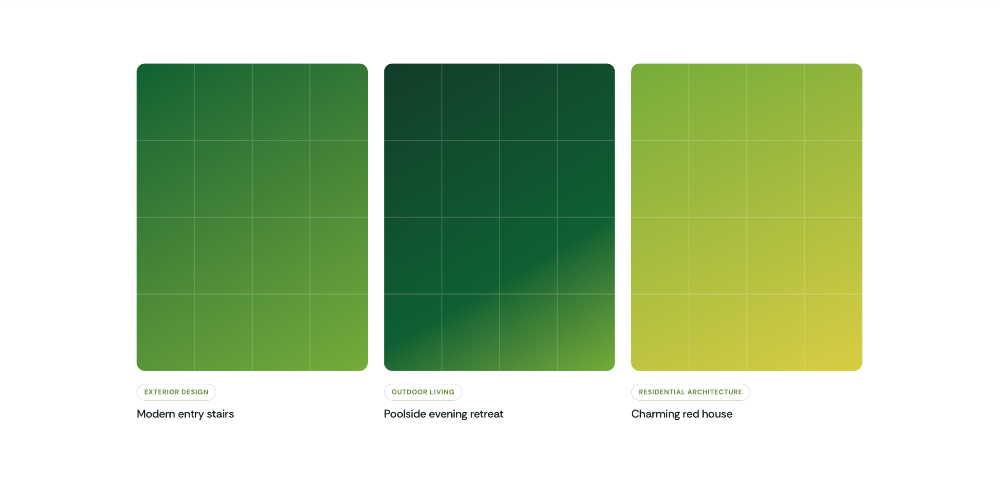

SECTION 03:
KEEP ONLY TWO CARDS. CONTENT:
OUR LOCATIONS

BANGALORE
MYSORE

OUR EXPERTISE:

Land Development
Identifying and developing plotted land opportunities with a focus on location, planning and long-term value.
Land Aggregation & Structuring
Bringing together landowners, capital and development opportunities through structured partnerships and JDA relationships.

Investment & Financial Structuring
Applying strong financial expertise to evaluate opportunities, structure capital and build financially sound projects.

DELETE THIS SECTION:
